PARNASSUS LETTERMAN’S SWEATER
Order Form

First Name: ________________________ Last Name: ____________________ Order #: ________

Phone #: ____________________ Student First/Last Name: _______________________ Grade: ________

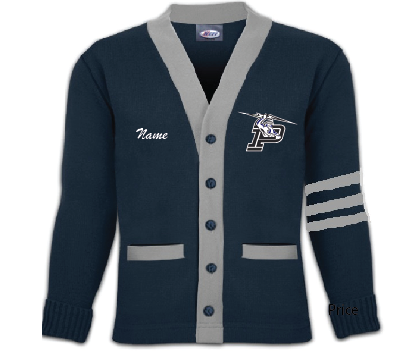

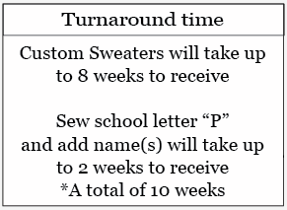
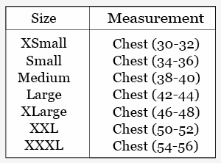

ORDER BEFORE Monday, March 1st

Letterman’s Sweater |  |  |  |  |  | Color: Navy/Grey |  |  | $155.00 ea.
XS | S | M | L | XL | 2XL *add $2 |  | 3XL *add $4 |  | Qty | Price

Purchase School Letter “P” | $17.00 |  | Sew school Letter  on Sweater | $7.00 ea.
Qty | Price |  | Qty | Price

Add a Name(s) |  | Color: White |  | $6.00 ea.
Enter Size | Enter First OR Last Name ONLY  (Will not fit both first and last name) |  |  | Qty | Price

MAKE CHECKS PAYABLE TO:  Parnassus Preparatory School  CONTACT INFORMATION:  NAME: Ms. Baddin  PH: 763-496-1416 ext. 290  Email: baddin@parnassusprep.com | TOTAL QTY  TOTAL PRICE $  PAID YES NO  TYPE OF PAYMENT CASH CHECK
*We do have sizing samples in the store. No appointments needed.

